Commerce on Rails™ for newline Creations, LLC

Database Requirements and Architecture

March 20, 2006

Group Six:
Rachel Messham
Lukasz Karapuda
Dick Granberg
Michael Mayer

Information Technology Masters Capstone
ITEC-6800

Prof. Hughes

Database Requirements

Client requirements

Commerce on Rails (COR) is intended to integrate with existing processes, hardware, and software at newline Creations. Since newline currently uses the MySQL database management system (DBMS) in production work, MySQL was an obvious choice. The advantages are that it is open source, low cost, easy-to-use and maintain, and extremely flexible. In addition, it comes installed with the RedHat Enterprise ES 4.0 operating system (which is on the newline servers) and it is fully supported by Rackspace (the newline hosting provider). It was, therefore, the default selection, as long as it met the remainder of the project database requirements. Consideration was given to use of the current version (v. 5.0) which offers some upgrades and benefits, including support for triggers, views, stored routines, and performance enhancements. Version 4.1 was selected because newline uses MySQL v. 4.1 currently in all existing development and production servers, and it met all project technical requirements.

Hardware and system requirements

Hardware and system requirements that affect database choice and design were the configuration of the existing newline servers, which run Redhat Linux ES 4.0, and the hardware requirements of the DBMS chosen. Since the existing servers meet the MySQL 4.1 hardware requirements, and MySQL 4.1 is compatible with the operating system, it continued to be the default DBMS choice.

Security and reliability requirements

In the case of COR, a role-based permissions and access control system is implemented as part of the application. No special DBMS features are required. Since a COR instance is expected to be available continuously, the DBMS cannot require any periods of unavailability for routine administrative functions. All MySQL databases on the newline servers are backed up daily using a managed backup device to ensure that information is safe in case an unexpected situation should occur. It is anticipated that each installed instance of COR will reside on servers with similar backup management plans.

Data integrity and business rules

No special functionality for maintenance of data integrity is required of the DBMS, since this control will be implemented within the application. In addition, COR business rules do not reside within the database, but are defined and implemented as methods of the COR model classes. There are, therefore, no specific requirements for support of triggers or stored procedures by the DBMS. A standard relational database model is presumed, however.

Performance requirements

Since a separate database will be created for every COR instance, and each installation will serve a single website, performance variables are minimized. Several of the tables, particularly “Orders” and its associated tables, would be expected to grow very rapidly with time. Therefore, the scalability of the database is important with respect to table size. Selected indexing is utilized for efficient searching within these tables to provide this scalability. Although not yet part of the application design, an archive mechanism is being considered to archive old records.

General database design

As discussed in the section “General Database Architecture and Design” below, each COR instance is intended to incorporate a dedicated, centralized database serving one website. Therefore, there is no need to implement any type of distributed database design, and there are no identified needs for data fragmentation or replication. An interesting aspect of the COR design is that the application and the database are coupled using the object-relational mapping layer of the Rails framework, called Active Record. This layer returns results of data requests as object instances rather than as data sets. This allows business rules and other logic to be incorporated as object methods, rather than being built into the database as triggers, constraints, or stored procedures.

General Database Architecture and Design

The general database and application architecture is shown in Figure 1 below. Rather than being implemented as a typical client-server relational database, the application relies upon the Active Record object-relational mapping layer in Rails to handle requests for data, and to instantiate data objects. All of the business rules and other logic that might typically be embedded in the database in constraints, triggers or stored procedures, are instead defined within the methods of the classes that are mapped to the database tables. Some of the advantages of this approach are that the application gains greater control over data manipulation and presentation, and individual requests for data tend to be smaller and simpler that with more traditional query methods.

Views

Views can be implemented in any way the developer chooses, since the Commerce API exposes all of the functionality of the application. This includes the customer interface, inventory maintenance interface, order processing interface, and related interactions.

Top level domain model

The top level domain model is shown in Figure 2 below. The major classes (entities) in the model are categories, products, customers, and orders. Line items are then associations between orders and products. The categories class can be self-referential, in that a category can be either a super-category or a sub-category of another category. The product class has a related class of product options that encapsulate the allowed product variations available to customers.

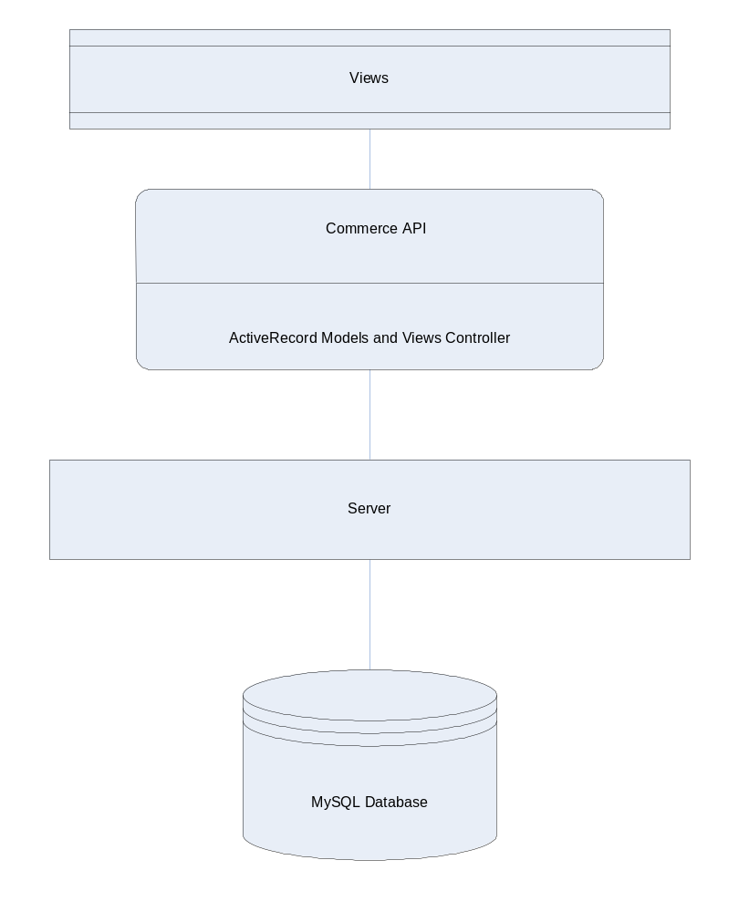
Figure 1

.
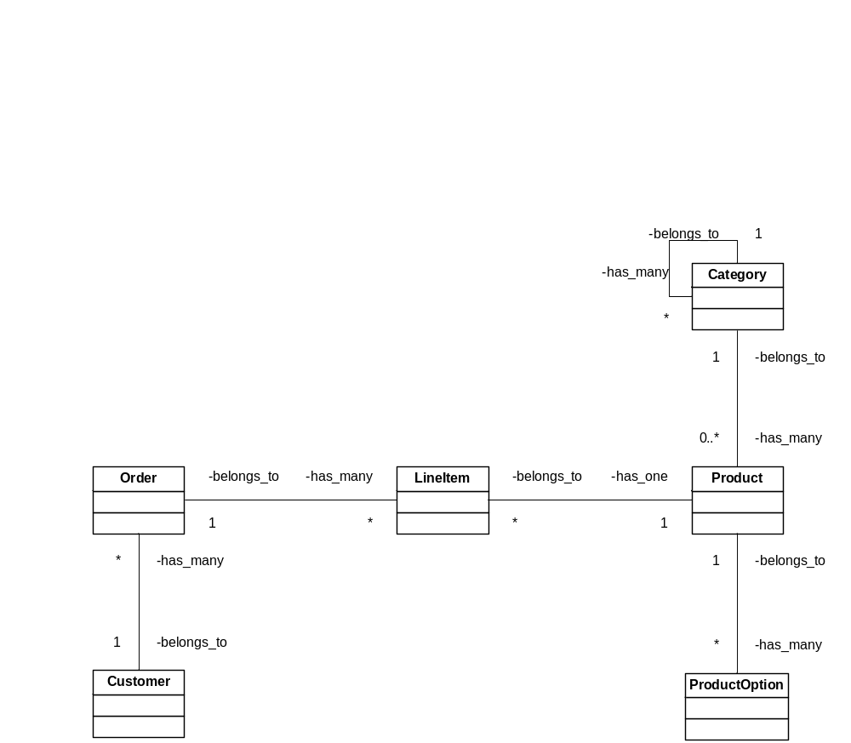
Figure 2

Database Specifics

The actual database schema is shown in Figures 3 and 4 below. It includes the complete set of model classes that represent the database relations. The cardinalities of the associations are as shown:
- customer to addresses (1:N)
- customer to payment_methods (1:N)
- customer to orders (1:N)
- global_payment_method to payment_methods (1:N)
- order to line_items (1:N)
- category to category_tags (1:N)
- category to category_image (1:N)
- category to category (category_id in the categories table represents the parent of the category in question) (1:N)
- category to products (1:N)
- product to product_tags (1:N)
- product to product_images (1:N)
- product to product_options (1:N)
- product to product_extra_fields (1:N)
- global_product_option to product_options (1:N)
- global_product_extra_field to product_extra_fields (1:N)
Note that there is no association from product to line_items (although one is implied in Figure 2). This is done to simplify data preservation and archiving (as discussed below), and to simplify queries (fewer joins).

Normalization issues

The entire design would be in Boyce-Codd Normal Form (BCNF), except that specific parts of the design have been denormalized. The orders and line_items relations, in particular, depart from BCNF. By design, the orders relation duplicates a good deal of customer, address and payment_method data. Again by design, line_items duplicates a good deal of product_data. The reason for this deviation from BCNF is that data in an order must never change. To truly achieve BCNF, the orders and line_items tables would have foreign keys to the data that is presently duplication. If this were the case, any changes to a customer profile, address, payment_method, or a product would result in loss of order data. In addition, this denormalization simplifies queries (fewer joins) and makes archiving easier.

Indexing

Selected indexes will be maintained to facilitate joins.

Attachment 1 shows the complete database structure, including fields, data types, keys, and default values.
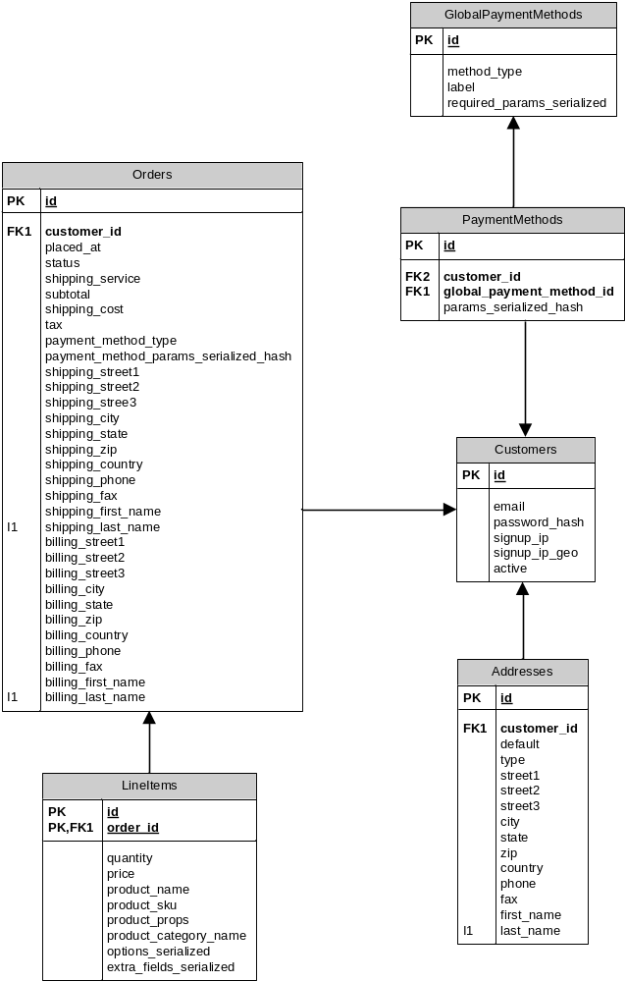
Figure 3
Figure 3

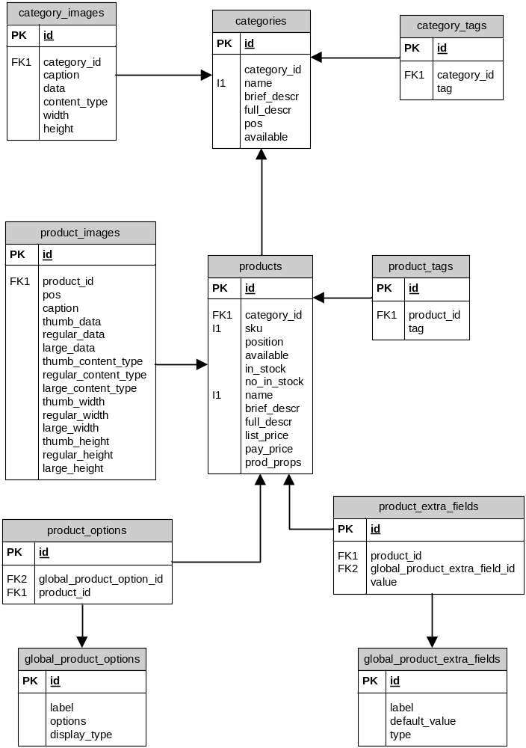
Figure 4
addresses | id (PK) | integer | 0 | true
 | customer_id (FK) | integer | 0 | false
 | default | bool | true | false
 | type | string | “shipping” | false
 | street1 | string | “”
 | street2 | string | “”
 | street3 | string | “”
 | city | string | “”
 | state | string | “”
 | zip | string | “”
 | country | string | “”
 | phone | string | “”
 | fax | string | “”
 | first_name | string | “”
 | last_name | string | “”
categories | id (PK) | integer | 0 | true
 | category_id | integer | 0 | false
 | name | string | “” | false
 | brief_descr | text
 | full_descr | text
 | pos | integer | 0 | false
 | available | bool | true | false
category_images | id (PK) | integer | 0 | true
 | category_id (FK) | integer | 0 | false
 | caption | string | “” | false
 | data | binary | “” | false
 | content_type | string | “” | false
 | width | integer | 0 | false
 | height | integer | 0 | false
category_tags | id (PK) | integer | 0 | true
 | category_id (FK) | integer | 0 | false
 | tag | string | “” | false
customers | id (PK) | integer | 0 | true
 | email | string | “” | false
 | password_hash | string | “” | false
 | signup_ip | string | “”
 | signup_ip_geo | string | “”
 | active | bool | true | false
global_payment  _methods | id (PK) | integer | 0 | true
 | method_type | string | “” | false
 | label | string | “” | false
 | required_params_serialized | text
global_product  _extra_fields | id (PK) | integer | 0 | true
 | label | string | “” | false
 | default_value | text
 | type | string | “” | false
global_product_options | id (PK) | integer | 0 | true
 | label | string | “” | false
 | options | text | “” | false
 | display_type | string | “” | false
line_items | id (PK) | integer | 0 | true
 | order_id (FK) | integer | 0 | false
 | quantity | integer | 1 | false
 | price | float | 0.0 | false
 | product_name | string | "" | false
 | product_sku | string | "" | false
 | product_props | text
 | product_category_name | string | "" | false
 | options_serialized | text
 | extra_fields_serialized | text
orders | id (PK) | integer | 0 | true
 | customer_id (FK) | integer | 0 | false
 | placed_at | datetime | false
 | status | string | "" | false
 | shipping_service | string | ""
 | shipping_cost | float | 0.0 | false
 | subtotal | float | 0.0 | false
 | tax | float | 0.0 | false
 | payment_method_type | string | "" | false
 | payment_method_params_serialized_hash | text
 | shipping_street1 | string | ""
 | shipping_street2 | string | ""
 | shipping_street3 | string | ""
 | shipping_city | string | ""
 | shipping_state | string | ""
 | shipping_zip | string | ""
 | shipping_country | string | ""
 | shipping_phone | string | ""
 | shipping_fax | string | ""
 | shipping_first_name | string | ""
 | shipping_last_name | string | ""
 | billing_street1 | string | ""
 | billing_street2 | string | ""
 | billing_street3 | string | ""
 | billing_city | string | ""
 | billing_state | string | ""
 | billing_zip | string | ""
 | billing_country | string | ""
 | billing_phone | string | ""
 | billing_fax | string | ""
 | billing_first_name | string | ""
 | billing_last_name | string | ""
payment_methods | id | integer | 0 | true
 | customer_id | integer | 0 | true
 | global_payment_method_id | integer | 0 | false
 | params_serialized_hash | text
product_extra_fields | id (PK) | integer | 0 | true
 | product_id (FK) | integer | 0 | false
 | global_product_extra_field_id (FK) | integer | 0 | false
 | value | text
product_images | id (PK) | integer | 0 | true
 | product_id (FK) | integer | 0 | false
 | pos | integer | 0 | false
 | caption | string | "" | false
 | thumb_data | binary | "" | false
 | regular_data | binary | "" | false
 | large_data | binary | "" | false
 | thumb_content_type | string | "" | false
 | regular_content_type | string | "" | false
 | large_content_type | string | "" | false
 | thumb_width | integer | 0 | false
 | regular_width | integer | 0 | false
 | large_width | integer | 0 | false
 | thumb_height | integer | 0 | false
 | regular_height | integer | 0 | false
 | large_height | integer | 0 | false
product_options | id (PK) | integer | 0 | true
 | global_product_option_id (FK) | integer | 0 | false
 | product_id (FK) | integer | 0 | false
product_tags | id (PK) | integer | 0 | true
 | product_id (FK) | integer | 0 | false
 | tag | string | “” | false
products | id (PK)
 | category_id (FK) | integer | 0 | false
 | sku | string | "" | false
 | pos | integer | 0 | false
 | available | boolean | true | false
 | in_stock | boolean | true | false
 | no_in_stock | integer
 | name | string | "" | false
 | brief_descr | text
 | full_descr | text
 | list_price | float
 | pay_price | float | 0.0 | false
 | prod_props | text

